1. CellAutoMachine: the source code.
2. Run the command in the file aca.bat on the terminal.
3. Instructions for using the simulator

Instructions for using the simulator：

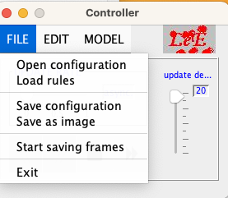

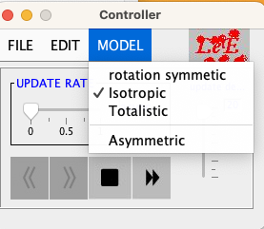

First：load rule.txt from the aca file





Then:open cofigurations of element from aca file





Final: click the start button

